**3.REACT JS – HOL**

**OBJECTIVES**

1. What is a React Component?

A React Component is a reusable block of UI code used to build parts of a webpage.

* Think of components as custom HTML elements.
* Each component can have its own structure (HTML), behavior (JS), and style (CSS).

Example:  
<CalculateScore /> is a component.

There are 2 main types:

* Function Components
* Class Components

2. Difference: React Components vs. JavaScript Functions

| Feature | JavaScript Function | React Component |
| --- | --- | --- |
| Purpose | General logic | UI building |
| Return | Any data | JSX (HTML-like code) |
| Usage | Called manually | Used in JSX like <Component /> |
| Lifecycle | No lifecycle | Has lifecycle (in class components) |

3. Types of Components in React

1. Function Component – Uses simple functions and hooks.
2. Class Component – Uses ES6 classes with lifecycle methods.
3. *(Bonus)* Higher-Order Components, Pure Components, etc. (Advanced)

4. What is a Class Component?

A class component is a component written using ES6 class.

It has:

* constructor()
* render() method
* Lifecycle methods like componentDidMount()

Example:

import React, { Component } from 'react';

class Welcome extends Component {

constructor(props) {

super(props);

this.state = { name: 'React' };

}

render() {

return <h1>Welcome to {this.state.name}</h1>;

}

}

5. What is a Function Component?

A function component is written using a simple JavaScript function.

It:

* Receives props as arguments
* Returns JSX

Example (from your project):

function CalculateScore(props) {

return <p>Name: {props.name}</p>;

}

Now preferred in modern React because of hooks like useState, useEffect.

6. What is a Component Constructor?

The constructor is a special method used only in class components.

* It's used to initialize state and bind methods.

Example:

constructor(props) {

super(props); // Required

this.state = { count: 0 };

}

You don’t need constructor() in function components.

7. What is the render() Function?

The render() function is used in class components.

* It returns JSX (the UI).
* Called automatically whenever the component updates.

Example:

render() {

return <h1>Hello React</h1>;

}

Function components don’t have render() — they directly return JSX.

**STEPS :**

**Step 1: Create a React App**

Open Visual Studio Code  
Open Terminal in VS Code (Ctrl + `)

**Code**  
npx create-react-app scorecalculatorapp

**Step 2: Open the Project in VS Code**

cd scorecalculatorapp

code .

**Step 3: Create "Components" Folder and File**

Inside src folder:

1. Right-click src → **New Folder** → name it Components
2. Right-click Components → **New File** → name it CalculateScore.js
3. Write code inside it.

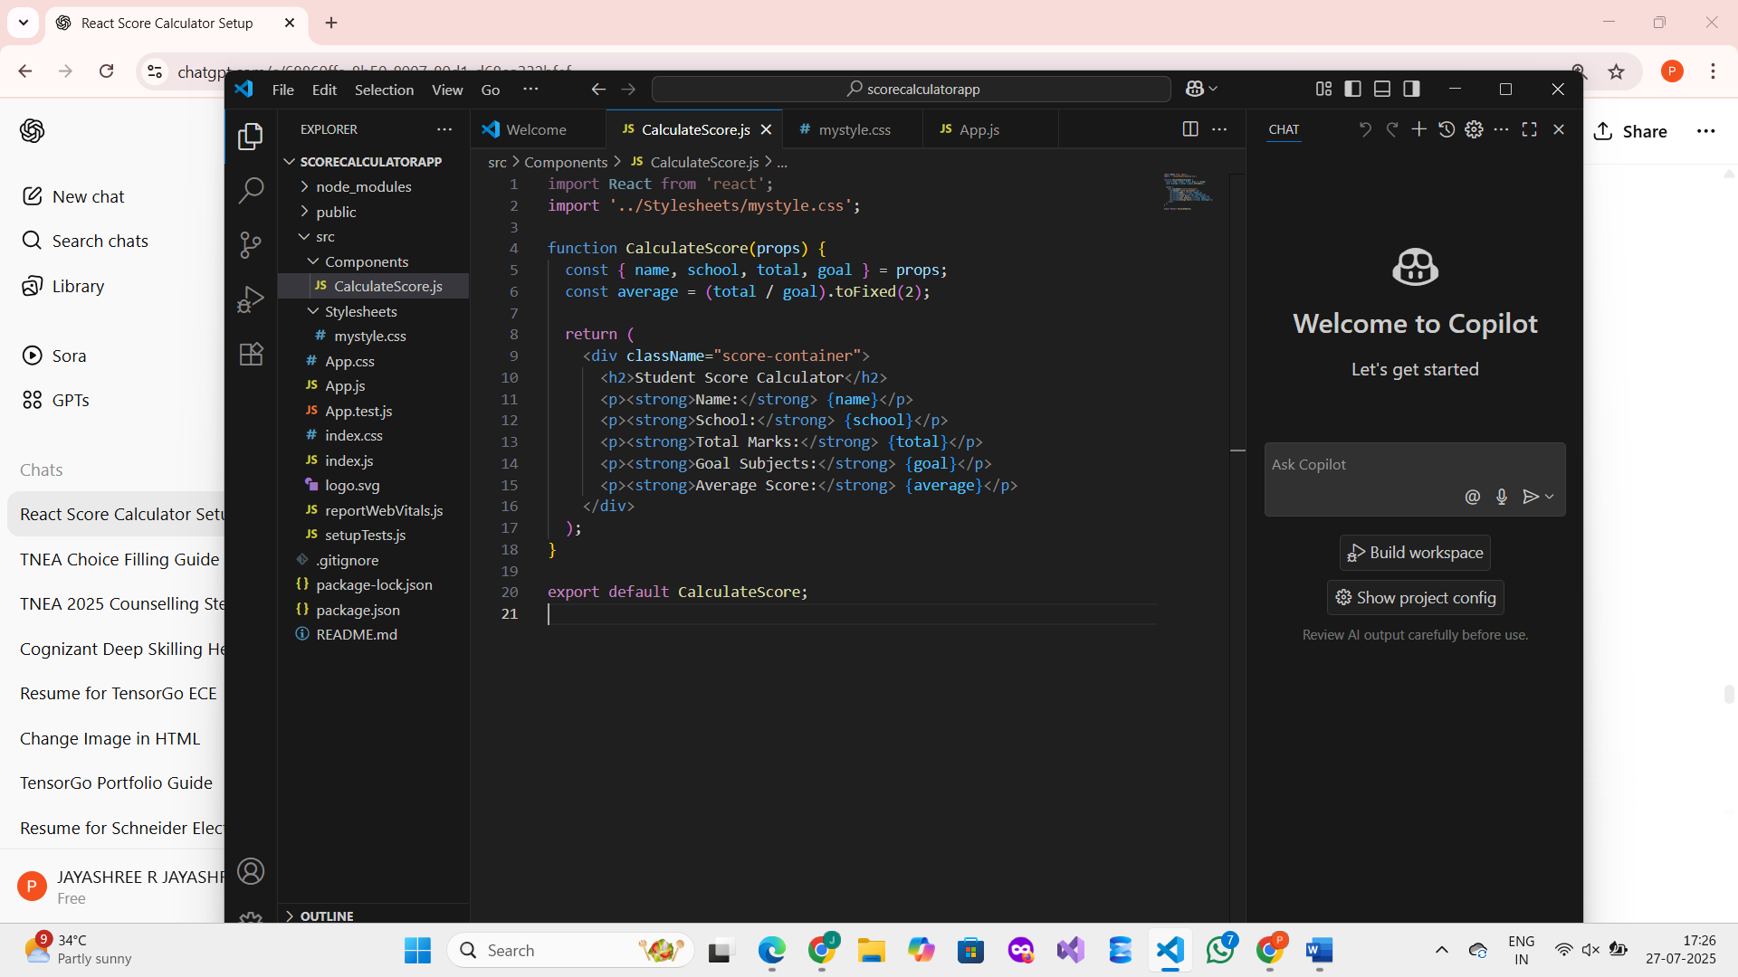

**Step 5 : Create a Stylesheet**

Inside src:

1. Right-click src → **New Folder** → name it Stylesheets
2. Right-click Stylesheets → **New File** → name it mystyle.css

Paste the following CSS inside mystyle.css:  
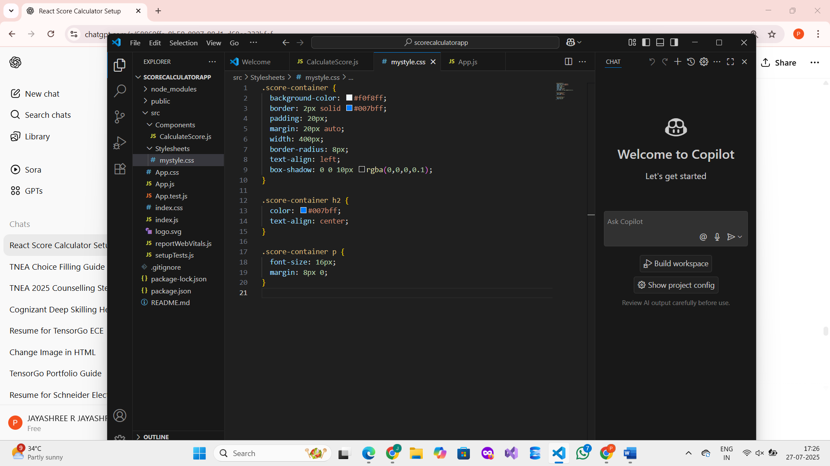

**Step 6 : Edit App.js to Render Component**

Replace everything in src/App.js with the following:

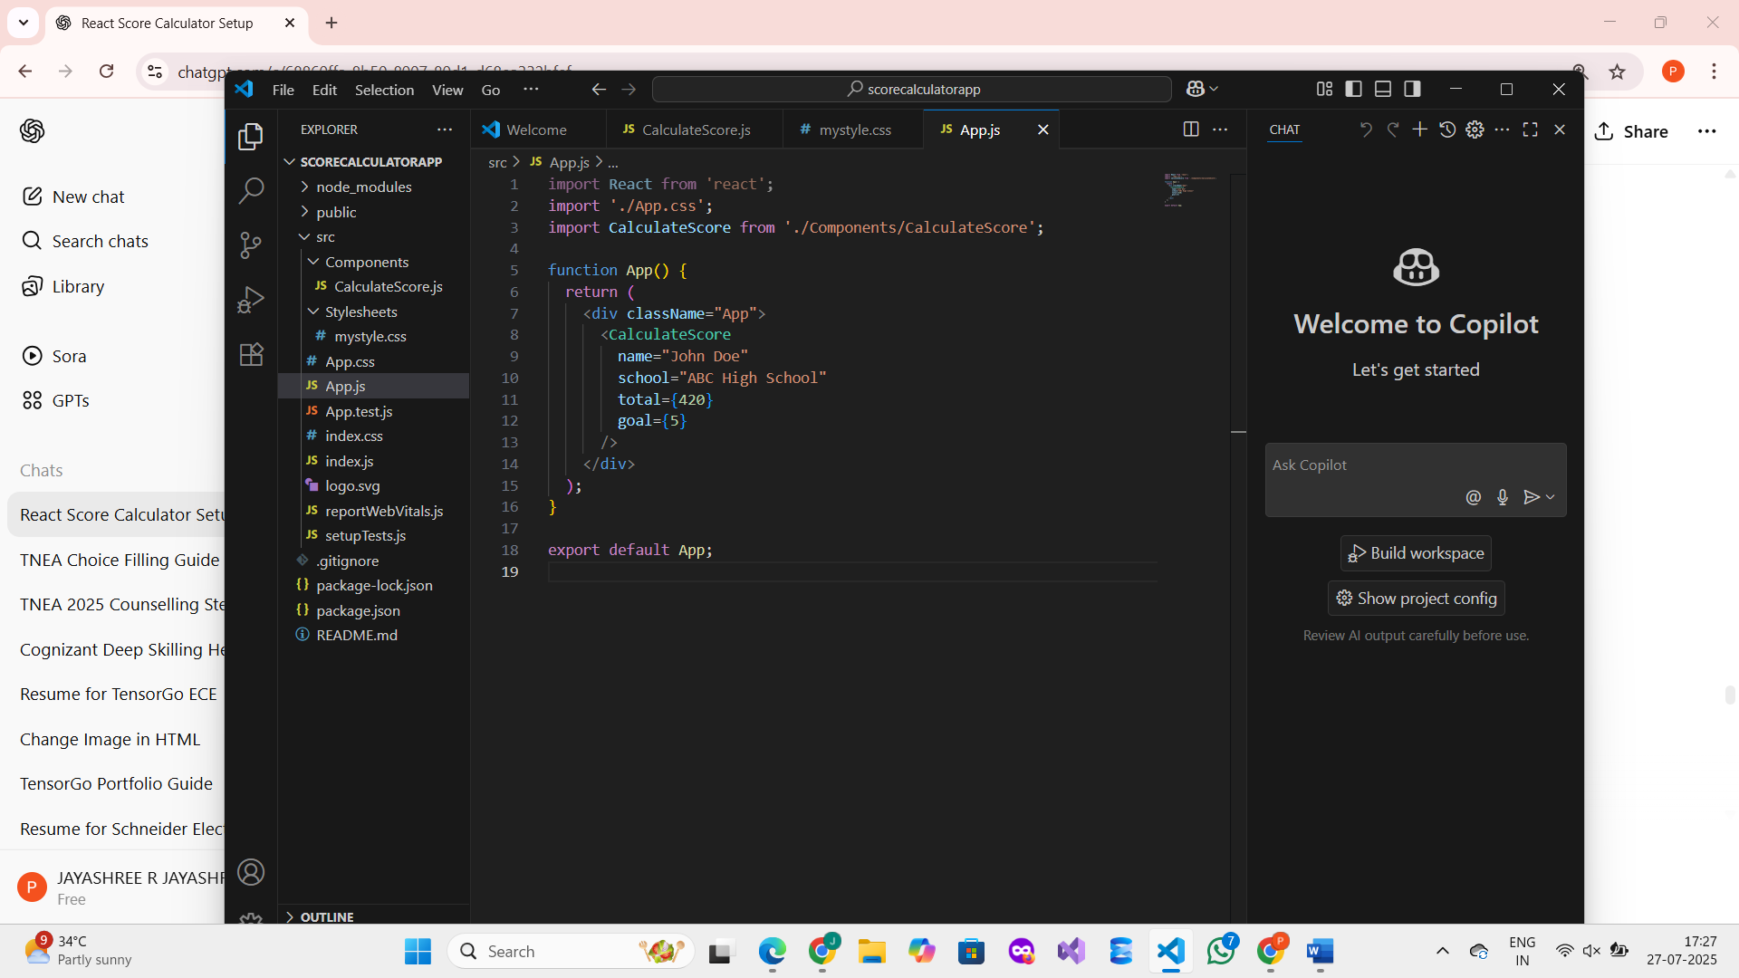

**Step 7: Run the React App**

Go back to your terminal inside the project folder (scorecalculatorapp) and type:

npm start

**Step 8: View the App in Browser**

Once it compiles, your default browser will open automatically.  
Or you can open it manually by typing:

